Python Django Web framework
Experiment – 4.1
Aim:
How to setup a project?
Program:
Create a folder and switch to folder-cd Django
- Install python –python.org
Check version – python --version
- Install pip-
Check version- pip --version

- Install virtual environment- Enter following command in cmd-
pip install virtualenv
- Set Virtual environment-
virtualenv env_site or python –m virtualenv env_site
- Change directory to env_site by this command-
cd env_site
- Go to Script directory inside env_site and activate virtual environment-
cd Scripts
activate *once activated change directory,go to
Django folder
7.Install Django
pip install django ,check version- django-admin --version

Creating a Project
Lets’ check how to create a basic project using Django after you
have installed it in your pc.
  - To initiate a project of Django on Your PC, open Terminal and Enter the following command
django-admin startproject projectName
Example- django-admin startproject mysite
  - A New Folder with name mysite will be created. To enter in the project using terminal enter command
cd projectName ,Eg: cd mysite
Now run,
python manage.py runserver
Now visit http://localhost:8000/

Creating an App

To create a basic app in your Django project you need to go to directory containing manage.py and from there enter the command :
python manage.py startapp projectApp
Example- python manage.py startapp polls
Now you can see your directory structure as under :

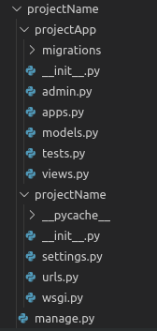

To consider the app in your project you need to specify your project name in INSTALLED_APPS list as follows in settings.py:
Application definition

INSTALLED_APPS = [
'django.contrib.admin',
'django.contrib.auth',
'django.contrib.contenttypes',
'django.contrib.sessions',
'django.contrib.messages',
'django.contrib.staticfiles',
'projectApp.app.projectAppConfig', ]
Experiment – 4.2
Aim:
How to display Hello World in browser using Django?
Program:
- Create an app
python manage.py startapp polls
That’ll create a directory polls, which is laid out like this: 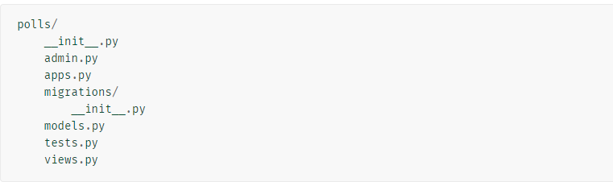
- Write your first view
Open the file polls/views.py and put the following Python code in it:
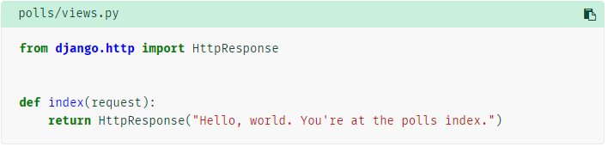
3. To call the view, we need to map it to a URL - and for this we need a URLconf.
To create a URLconf in the polls directory, create a file called urls.py.
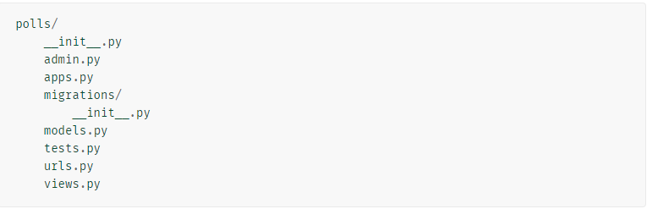

4.In the polls/urls.py file include the following code:
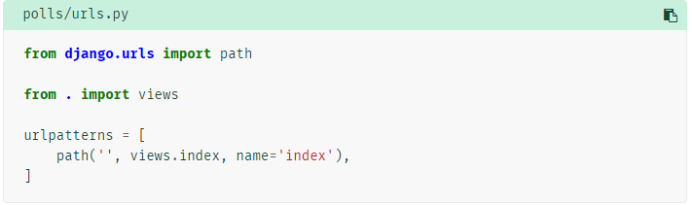
- The next step is to point the root URLconf at the polls.urls module. In mysite/urls.py, add an import for django.urls.include and insert an include() in the urlpatterns list, so you have:
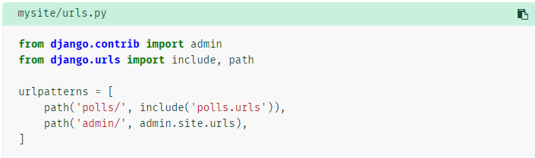

- Run the server
python manage.py runserver
Go to http://localhost:8000/polls/ in your browser, and you should see the text “Hello, world. You’re at the polls index.”, which you defined in the index view.

Experiment – 4.3
Aim:
How to apply migrations & What is migrations does?
Program:

Database setup
Now, open up mysite/settings.py. It’s a normal Python module with module-level variables representing Django settings.
By default, the configuration uses SQLite. If you’re new to databases, or you’re just interested in trying Django, this is the easiest choice.
If you wish to use another database, install the appropriate database bindings and change the following keys in the DATABASES 'default' item to match your database connection settings:
- ENGINE – Either 'django.db.backends.sqlite3', 'django.db.backends.postgresql', 'django.db.backends.mysql', or 'django.db.backends.oracle'. Other backends are also available.
- NAME – The name of your database. If you’re using SQLite, the database will be a file on your computer; in that case, NAME should be the full absolute path, including filename, of that file. The default value, BASE_DIR / 'db.sqlite3', will store the file in your project directory.
mysite/settings.py
By default, INSTALLED_APPS contains the following apps, all of which come with Django:
- django.contrib.admin – The admin site. You’ll use it shortly.
- django.contrib.auth – An authentication system.
- django.contrib.contenttypes – A framework for content types.
- django.contrib.sessions – A session framework.
- django.contrib.messages – A messaging framework.
- django.contrib.staticfiles – A framework for managing static files.
These applications are included by default as a convenience for the common case.
python manage.py migrate
The migrate command looks at the INSTALLED_APPS setting and creates any necessary database tables according to the database settings in your mysite/settings.py file and the database migrations shipped with the app.

Before migrations
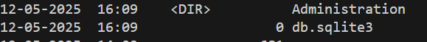
After migrations
python manage.py migrate
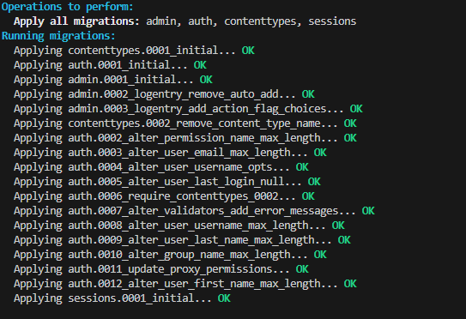
Check database size –dir
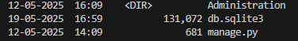

By running makemigrations, you’re telling Django that you’ve made some changes to your models
Make migrations follow Exp 4.5
- Create a Model
- Change settings.py
- After type python manage.py makemigrations appname
- Python manage.py migrate
- Check database size-dir

Experiment – 4.4
Aim:
How to access Django admin panel?
Program:

Creating an admin user
python manage.py createsuperuser
Enter your desired username and press enter.
You will then be prompted for your desired email address:
The final step is to enter your password. You will be asked to enter your password twice, the second time as a confirmation of the first.
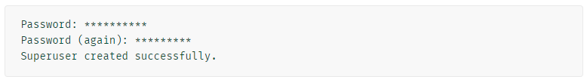

Start the development server
The Django admin site is activated by default. Let’s start the development server and explore it.
python manage.py runserver
Now, open a web browser and go to “/admin/” on your local domain – e.g., http://127.0.0.1:8000/admin/. You should see the admin’s login screen
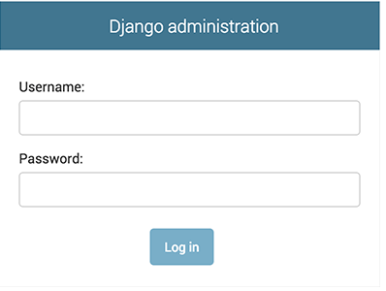
Experiment – 4.5
Aim:
How to create a table in database & what is ORM?
Program:
Edit the polls/models.py
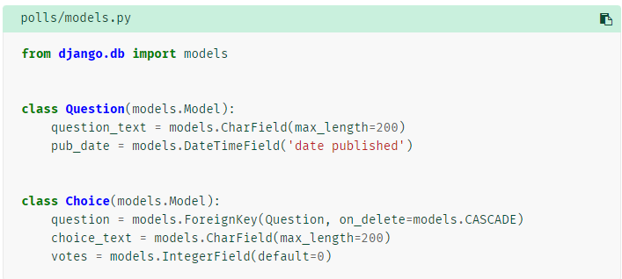

Example 2
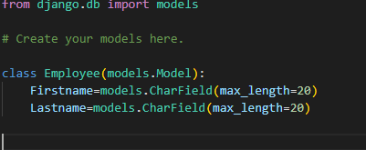

Activating models
First we need to tell our project that the polls app is installed.
To include the app in our project, we need to add a reference to its configuration class in the INSTALLED_APPS setting. The PollsConfig class is in the polls/apps.py file, so its dotted path is 'polls.apps.PollsConfig'. Edit the mysite/settings.py file and add that dotted path to the INSTALLED_APPS setting. It’ll look like this:
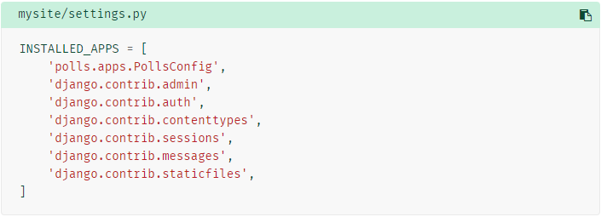
Now Django knows to include the polls app. Let’s run another command:
python manage.py makemigrations polls
You should see something similar to the following:
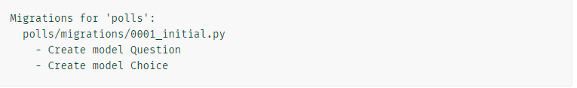
Now, run migrate again to create those model tables in your database:
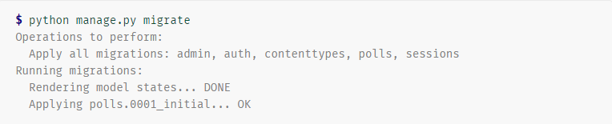
- Change your models (in models.py).
- Run python manage.py makemigrations to create migrations for those changes
- Run python manage.py migrate to apply those changes to the database.

Make the poll app modifiable in the admin(Models)
We need to tell the admin that Question objects have an admin interface. To do this, open the polls/admin.py file, and edit it to look like this:
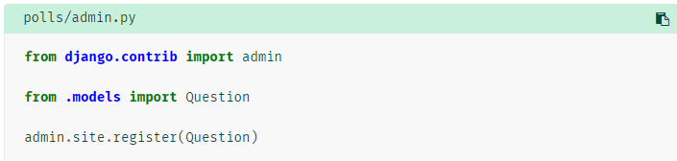
Experiment – 4.6
Aim:
How to connect MYSQL or … (except sqllite3) in a Django application?
Program:
- Create a database in XAMPP Server
- Create Models in model.py
- In settings .py change Database configuration as
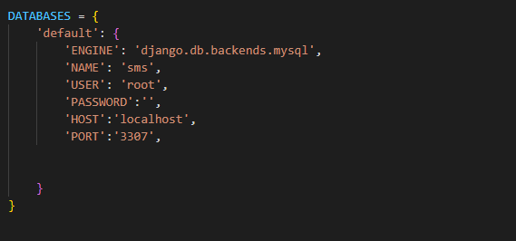

Engine –Database engine name
Name-Database name
User-username of the database

- Run the following commands
python manage.py makemigrations
python manage.py migrate

Experiment – 4.7
Aim:
What is Jinja? Displaying a list of items using Jinja for loop?
Program:
Polls/views.py
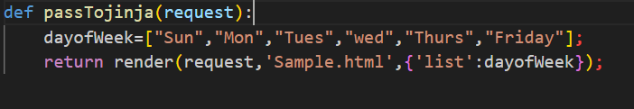
Polls/urls.py
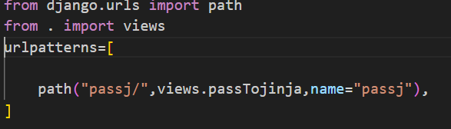
templates/b.html
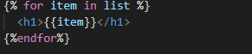
Settings.py
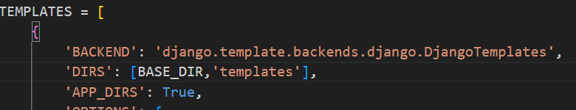
Or
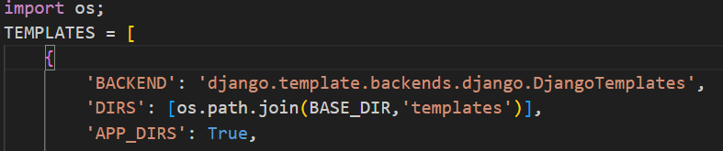

Run the server
Python manage.py runserver
Experiment – 4.8 -4.9
Aim:
How to methods like POST & GET works? and How to create form using models?
Program:
Create a model in model.py

templates/insert.html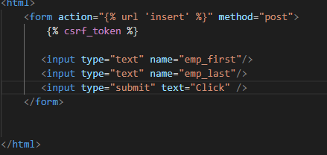

Polls/views.py
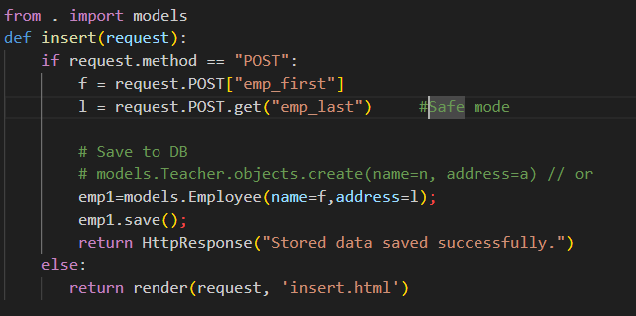

Polls/urls.py
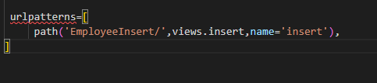


Run the server
python manage.py makemigrations polls
python manage.py migrate
python manage.py runserver
127.0.0.1:8000/polls/EmployeeInsert/

